NORTH CAROLINA STATE UNIVERSITY

Department of Mechanical and Aerospace Engineering

MAE 521 Robust Control with Convex Methods

Spring semester, 2017

Project: Aircraft Pitch Pointing and Vertical Translation Control

REPORT

By Yingxi Geng

**Introduction**

This project describes one open-loop aircraft system, with angle of attack, pitch rate, pitch attitude, elevator deflection and flaperon deflection as states. The main goal of the project is to design stable feedback system with satisfactory performance. The performance specifications have three components: command following, disturbance rejection, and insensitivity to sensor noise. It is important for model to greatly approach to good performance. Besides these specifications, other conditions should also be satisfied: minimize the steady-state error, minimize the cost of system, and limit the normal acceleration within 3g. In order to satisfy these conditions, several feedback systems will be developed and compared in this project.

**Dynamic model**

Suppose an aircraft model as:

+ **d**



where **x** is the state vector, **u** is the control vector, and **y** is the output vector as



where *nzp* is normal acceleration at the pilot’s station. **d** is disturbance input.



The output, where *nzp* is normal acceleration at the pilot’s station.



So.

,

**Approaches and solutions**

**Part 1:** examine the controllability and observability of the MINO and SISO systems.

1. For MIMO system, generate matrix of Mc and Mo and check their rank. If the rank of Mc is not full, the MIMO system is uncontrollable. Similar with Mo, if the rank of Mo is not full, the MIMO system is unobservable.



Rank (Mc) =5



Rank (Mo) =5.

So the MIMO system is both controllable and observable.

1. SISO system: with the same expression of Mc and Mo, test controllability and observability for each combination of SISO system. Since the controllability is only related to the A matrix and input B, examine the rank of Mc for both input separately.

Input 1:

, rank (Mc1) =4

Input 2:

, rank (Mc2) =4

Mc for both inputs are not full rank. It’s similar that observability of one system is only related to it’s A matrix and output C. So examine the rank of Mo for each output

Output1

, rank (Mo1) =3

Output 2:

, rank (Mo2) =3

Output 3:

, rank (Mo3) =4

All Mo for 3 outputs are not full rank. So each SISO system is not controllable and observable.

Table 1. Controllability and observability for SISO system with each combination of input and output

|  |  |  |  |
| --- | --- | --- | --- |
|  | Output 1 | Output 2 | Output 2 |
| Input 1 | Uncontrollable, unobservable | Uncontrollable, unobservable | Uncontrollable, unobservable |
| Input 2 | Uncontrollable, unobservable | Uncontrollable, unobservable | Uncontrollable, unobservable |

**Part 2:** Examine the open-loop system response to an impulse disturbance on angle of attack and step input change on both elevator and flaperon deflections, separately.

Use matlab to simulate two kinds of input signal into the system. Fig. 1 shows the responses to these two kinds of input signal. From the Fig. 1, it could be obtained that pitch attitude state has no response to both input signals. The response from normal acceleration changed greater than pitch rate. The step input of elevator and flaperon deflections influence responses more than one impulse disturbance on angle of attack state.

|  |  |
| --- | --- |
| a) | b) |

Fig 1. Open-loop system responses to a) impulse disturbance on angle of attack; b) step input change on elevator and flaperon deflections.

**Part 3 and part 4:** Design a full-state feedback system $u= -Fx+r$, where the feedback matrix *F* is 2x5 feedback gain matrix. Examine the SVD of the feedback system and comment on its min-max behavior

Requirements:

1. Minimize the steady-state error and pay close attention to the cost of control;
2. Shape the eigenvector directions for the first and the third states as follows;

,where X denotes ‘don’t care’ entries

1. Limit the normal acceleration output within 3.0 g.

Solution:

**First trial**

1. Examine the eigenvalues of the open loop system.

, , , , 

Notice that the eigenvalues of the open-loop system are not all negative, so the open-loop system is not stable.

1. Choose eigenvalues and eigenvectors for closed-loop.

Choose as the closed-loop poles. All the eigenvalues must be negative to ensure the stability of the system. Use MIMO eigenvector assignment to calculate matrix gain F. Set eigenvector P and matrix Q. P needs to satisfy the requirements 2 described above.





Use equation to calculate P and Q. Results are

,

Then use equation of feedback matrix gain that  to obtain F

.

So we get  and the new closed-loop system has a new A matrix that. Transfer function G is assembled by (AA, B, C, D)

1. evaluate the steady state error:

For steady state, ,

Treat reference input to be 1, then steady-state error: 

So it could be obtained that. The steady-state error is large, since this error is supposed to be approached to zero.

1. Get SVD and plot the max-min sinusoid input and output.

Find the frequency where G has its maximum singular value by using ‘sigma’ command in Matlab. In the Fig.2, it could be approximately estimated that when the frequency is about 10 rad/sec, G achieved its maximum singular value.

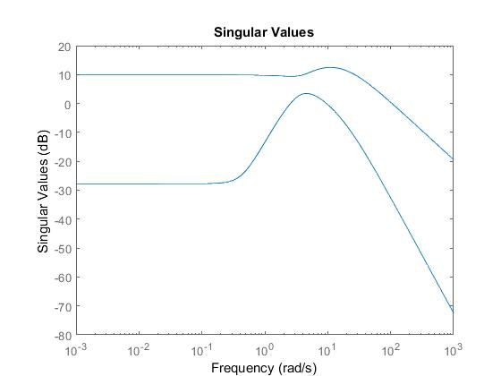

Fig 2. Maximum and minimum singular value for closed-loop transfer function G

Then set w=10 rad/sec, s=jw, to calculate the SVD for G (j10).







Fig. 3 and Fig. 4 show the sinusoid input and output responded to max and min behavior. It could be observed that in both figures, input of elevator deflection and flaperon deflection have similar amplification to achieve max or min outputs. But the phases for two inputs have different angles. Pitch rate always has greater responses compared to pitch attitude, which means the change of inputs has greater influences on pitch attitude. Fig. 3 shows that the maximum normal acceleration is about 5g, which obeys the requirement 3 of feedback design. So we want to perform a second trial to reduce the normal acceleration below 3g.

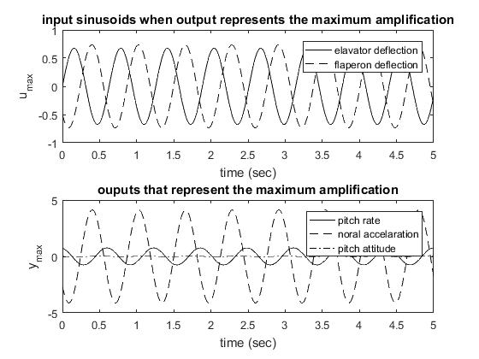

Fig 3. Sinusoid inputs and outputs responded to maximum output amplification (unit for normal acceleration is g, others are rad/sec)

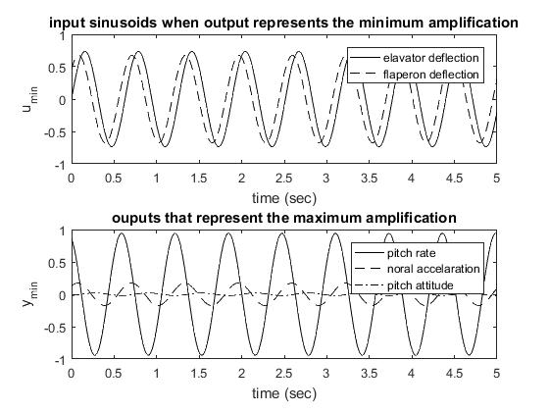

Fig 4. Sinusoid inputs and outputs that represent the minimum output amplification (unit for normal acceleration is g, others are rad/sec)

**Second trial**: increase the eigenvalues for closed-loop system to reduce the maximum output of normal acceleration

Choose eigenvalues: 

By using the same method described in first trial, it could obtained the feedback gain and steady-state error

, 

We only pay attention to the maximum normal acceleration in this trial, which is shown in Fig. 5. It is displayed in this figure that the maximum output of normal acceleration decreased to below 2.5g, which satisfied the requirement 3. However, the steady-state in this trial is still large. So we want to add one scaling matrix K before the reference input to minimize the steady state-error in the third trial.

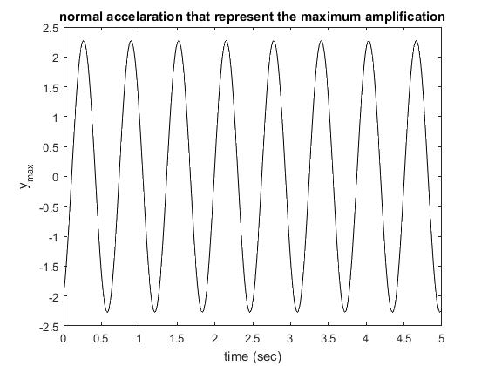

Fig 5. Maximum amplification of normal acceleration for second trial

**Third trial**: Add one scaling matrix K before r (keep the same F from second trial)

The input. Force the output equal to reference to get a zero steady-state error. With reference input to be 1, 

Shape C into 2 by 5 matrix by choosing q and  as output . Then calculate.

Then the new system is .

Evaluate the steady-state error and the maximum normal acceleration output (Fig. 6) for this new system:



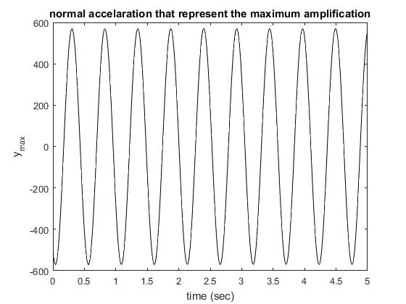

Fig 6. Maximum amplification of normal acceleration for third trial

From the Fig. 6, it could be seen that the maximum normal acceleration output is about 600g, which is much greater than the required 3g. The pilot cannot survive under this normal acceleration.

Thus, for this trial, although the steady-state error could be minimized to zero, the maximum amplification of normal acceleration is not accepted.

**Fourth trial**: shape matrix C by choosing q and nzp output, and calculate a scaling matrix K to minimize the steady state error.

From the third trial, we know that by minimizing the steady-state error from other output, the normal acceleration will reach a magnificent amplification. So at this trial, we try to minimize the steady-state error by normal acceleration output. So new C matrix is, and we obtain a scaling matrix.

Evaluate the steady-state error and the maximum normal acceleration output (Fig. 7) for this new system:



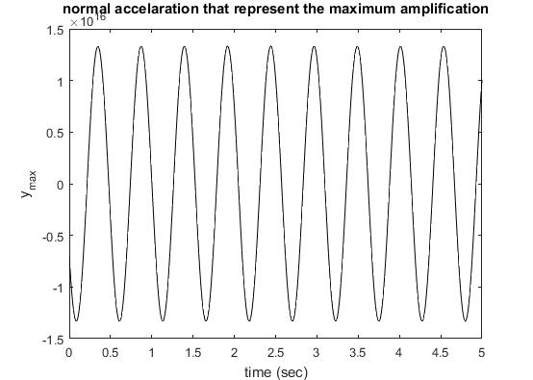

Fig 7. Maximum amplification of normal acceleration for fourth trial

From Fig.7, it could be obtained that the maximum output of normal acceleration is even greater the that from third tiral. So this trial cannot be applied on the feedback system

In the above content, we have designed four kinds of feedback system. The first one has a smaller feedback gain than other three, so it is the cheapest system among four. The second system has a large steady-state error, and this system is the only one that could ensure the maximum normal acceleration to be less than 3g. The third and fourth system have good steady-state error, but their amplification for normal acceleration is too large for pilot to tolerant it. So considering the safety of the pilot, it’s better to choose the second system as the feedback system with the sacrifice of steady-state error.

**Part 5**

Since the control of flaperon was disabled, so the output has variation by only changing input 2. So at second trial, set the full state feedback gain and test the system. Use sinusoid for input 2 with zero input 1. However, from the Fig. 8 a) the responses still changing with the time varying input. So set elements related to input 2 in B to be zero and get a time unvarying response to sinusoid input (shown in Fig. 8 b)).

So the new state space matrix will be:

, 

,

|  |  |
| --- | --- |
| a) | b) |

Fig 8. Reponses to test system: a) only elements in F related to input 2 were set to zero; b) elements in matrix A, B, C, and F related to input 2 were all set to zero

In order to minimize the sacrifice of the performance of the system in part 3, let the eigenvalues equals to those in second trial.



Set 

Use explicit method to get F that 

Obtain a feedback gain: 

By compared with feedback gain in part 3,, it is obvious that the gain for this part is greater than that for part 3. Since the input flaperon deflection lose its control ability, the feedback gain should take more control effort to make sure the system is under control. So the cost for this system is greater than that for part 3.

**Part 6:** Design an observer for the system (either full-state or reduced order) using output measurements of pitch rate and pitch attitude. Make sure that your observer dynamics is at least five times faster than your system dynamics.

A reduced order is designed below. Since the second and third state could be measured, the state-space model need to be manipulated as below





,,

The pole of fast mode of dynamic system is -18, and the observer dynamics should not less than five times the fast mode for system dynamics. So choose the pole of observer to be -90,-91,-92.

Generate an observer matrix.

Use the error dynamics  to obtain the L matrix,.

So the reduced order observer will be 



**Part 7:** Using the feedback of the observed states in Part 6, design a MIMO feedback system much like in Part 3 and compare the performances of the two systems. Examine the ‘cost’ involved in each of the approaches and make recommendation on which is ultimately the better design to use.

1. Derive the new state-space model for system by using the observed states.

The original state-space equation is expressed as



The measurable output



The observer:



Set:





So the new dynamic system:





Where the new state is, input is y, and output is u.

So new state- space realization:





1. Design a feedback gain F (2x3)

Use similar method in part 3 to calculate F. Choose eigenvalues 

Eigenvectors and Q are

, 

Then calculate P, Q, and F

, 



This feedback gain is much greater than the feedback gain in part 3 with similar eigenvalues assignment. So it takes this system more effort to control.

Estimate error and maximum normal acceleration output: . The steady-state error is still large.

**Evaluation:**

The evaluation of system performance including three specification in this report: command following (CF), disturbance rejection (DR), and insensitivity to sensor noise (IN). In order to obtain these three specifications, the closed-loop transfer matrix (C(s)), sensitivity transfer function matrix (S(s)), and loop transfer function matrix (T(s)) are need to be expressed for each feedback system.

For a feedback system with u=-Fx+r,



Use Laplace transformation,







So,



Also,





For T(s)





If the feedback system has a scaling matrix K multiplied before r, then







The command following is based on the maximum singular value of S(s). If the value is much smaller than 1 (), the commanding following is good in the system. The disturbance rejection depended on T(s) (). If the minimum singular value of T(s) is much greater than 1, the system has a good DR. Similarity, the insensitivity to noise depends on C(s), if the maximum singular value of C(s) is much smaller than 1 (), the system has good IN. Note: the vertical axis for singular value in is Db.

Now, plot the maximum and minimum singular value plot of C(s), S(s) and T(s) for each system.

1. System in part 3 first trial

From Fig. 9, we can conclude that is greater than 0 dB at both high and low frequency,  is about -20 dB at high frequency, and the peak of is lower than 1 dB. So the system has bad CF and DR, but the IN is good at high frequency (w>103 rad/sec)

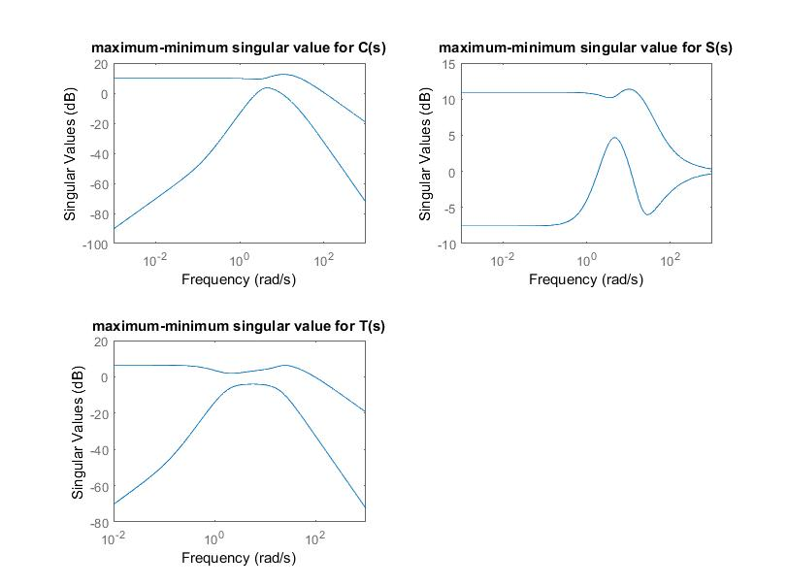

Fig. 9 maximum and minimum singular value for C(s), S(s) and T(s) for first trial

1. System in part 3 second trial

From Fig. 10, it could be obtained that is always greater than 0 dB,  is always greater than 0 dB, and is always lower than 0 dB. So all performance specifications for this system are not satisfied the constraint condition. So the system has bad performance.

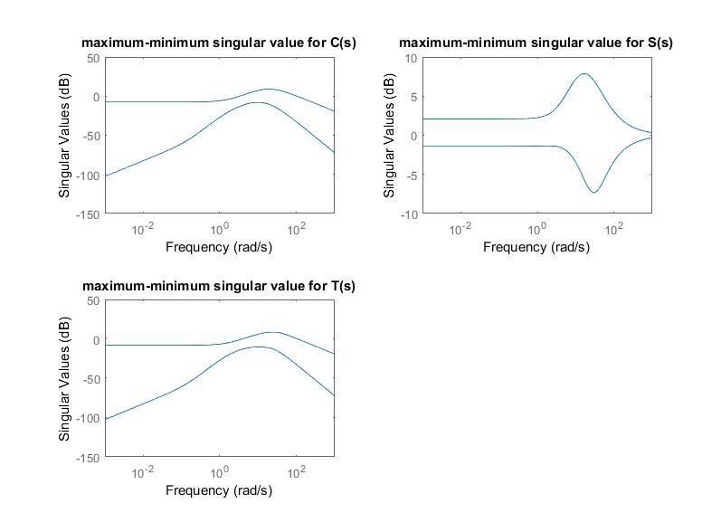

Fig. 10 maximum and minimum singular value for C(s), S(s) and T(s) for second trial

1. System in part 3 third trial

From Fig. 11, it could be obtained that is always greater than 0 dB,  is always lower than 0 dB at high frequency, and is always lower than 0 dB. So all performance specifications for this system are not satisfied the constraint condition. So the system has bad CF and DR, but the IN is good at high frequency (w>103 rad/sec)

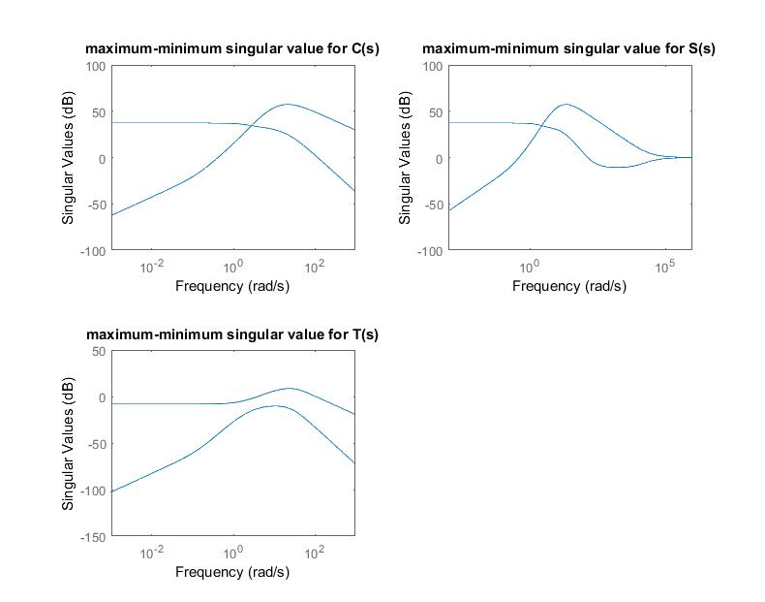

Fig. 11 maximum and minimum singular value for C(s), S(s) and T(s) in third trial

1. System in part 3 second trial

From Fig. 12, it could be obtained that is always greater than 200 dB,  is always greater than 200 dB, and is always lower than 0 dB. So all performance specifications for this system are not satisfied the constraint condition. So the system has bad performance.

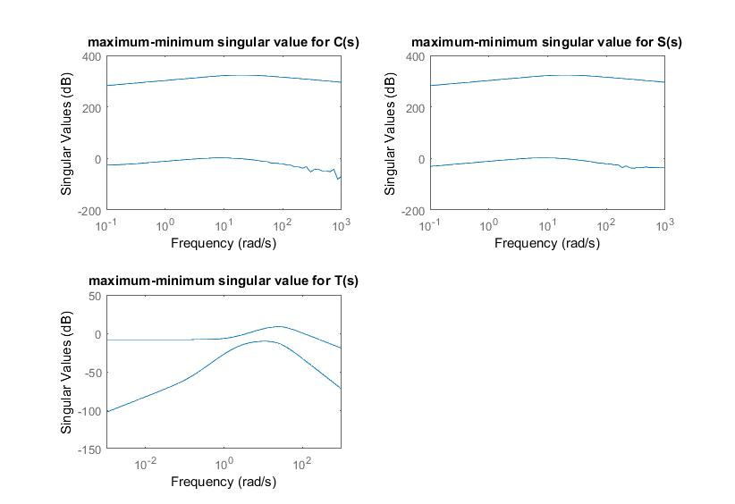

Fig. 12 maximum and minimum singular value for C(s), S(s) and T(s) in fourth trial

1. Feedback system in part 5- one input lose control

Since the output are zero to the input 2, so the closed-loop transfer function is singular matrix. Only the minimum singular value could be obtained for C(s) and S(s). As shown in Fig. 13, is always greater than 0 dB, and is always lower than 0 Db. So the system had bad performance at all frequency range.

1. Feedback system in part 7- feedback system by using the feedback of the observer state

From Fig. 14, it could be obtained that at low frequency, at high frequency, but is always lower than 0 dB. So the system has good CF, IN, but bad DR.

1. Comparison: All systems does not have satisfactory performance as expected. The fourth trial is the worst situation with much more greater magnitude for maximum singular value than other systems. The trial 1 is the best system among all systems, with a good IN performance. However, as mentioned in part 3 and 4, the normal acceleration for this system does not satisfy the design requirement. Although the trial 2 has worse performance than trial 1, for the safety of pilot, it’s better to choose this system. There are still couples of problems needed to be solved and optimized for this system.

When compared to the feedback system with state from observe, the performance of it is better than the second trial system. But from the system from part 7, the normal acceleration cannot be output. That is, the condition for pilot cannot be obtained directly, which may cause dangerous to pilot. So it still be better to choose the second trial feedback system. If the feedback system with observe could be upgraded to overcome the shortcoming, this system will be the best choice.

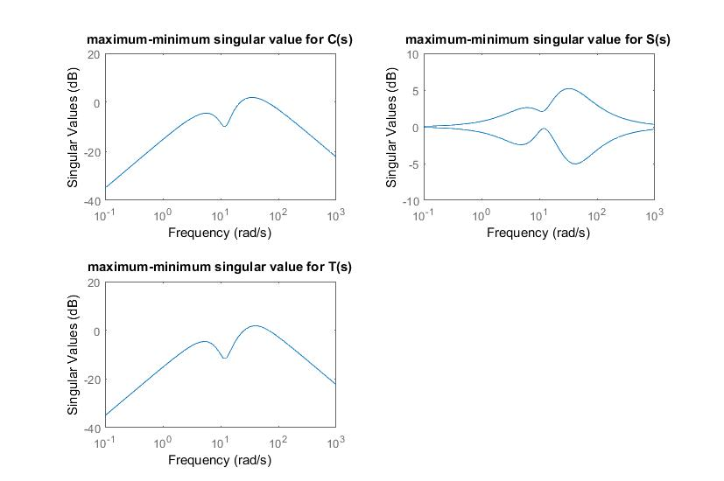

Fig. 13 maximum and minimum singular value for C(s), S(s) and T(s) in part 5

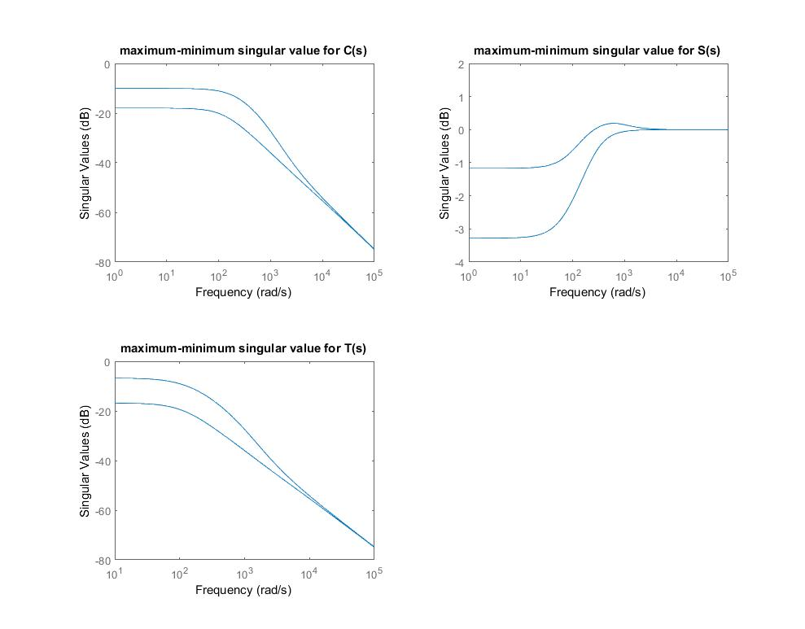

Fig. 14 maximum and minimum singular value for C(s), S(s) and T(s) in part 7

Appendix-A Matlab code for part 1—controllability and observability for MIMO and SISO system

clear all;

% Define state

A=[-1.3,0.98,0,-0.165,-0.248;42.81,-0.785,0,-17.3,-1.58;1.25,0.007,0,0.165,0.248;0,0,0,-18,0;0,0,0,0,-18];

B=[0,0;0,0;0,0;18,0;0,18];

C=[0,1,0,0,0;46.5,-0.256,0,-4.25,4.15;0,0,1,0,0];

D=[0,0;0,0;0,0];

[U,V]=eig(A)

% observable,controllable for MIMO

Mc=[B,A*B,A^2*B,A^3*B,A^4*B];

rank(Mc);

Mo=[C',A'*C',A'^2*C',A'^3*C',A'^4*C'];

rank(Mo);

%%

% Mc for input 1

B1=B(:,1);

C1=C(1,:);

Mc1=[B1,A*B1,A^2*B1,A^3*B1,A^4*B1];

rank(Mc1); %=4

% Mc for input 2

B2=B(:,2);

Mc2=[B2,A*B2,A^2*B2,A^3*B2,A^4*B2];

rank(Mc2); %=4

% Mo for output 1

Mo1=[C1',A'*C1',A'^2*C1',A'^3*C1',A'^4*C1'];

rank(Mo1); %=3

% Mo for output 2

C2=C(2,:);

Mo2=[C2',A'*C2',A'^2*C2',A'^3*C2',A'^4*C2'];

rank(Mo2); %=3

% Mo for output 3

C3=C(3,:);

Mo3=[C3',A'*C3',A'^2*C3',A'^3*C3',A'^4*C3'];

rank(Mo3); %=4

Appendix-B: Matlab code for part 2—responses to impulse disturbance on angle and attack, and step input on elevator and flaperon deflections

sys=ss(A,B,C,D);

t=0:0.001:10;

tt=transpose(t);

% impulse disturbance

figure(1)

BB=[B,[1;0;0;0;0]];

D=[D,[0;0;0]]

sys2=ss(A,BB,C,D);

dis=[1;zeros(size(transpose(0:0.001:9.999)))]

uu=[zeros(size(tt)) zeros(size(tt)) dis];

[Y,TT]=lsim(sys2,uu,t)

plot(TT,Y(:,1),'k',TT,Y(:,2),'K--',TT,Y(:,3),'K-.')

xlabel('Time(s)')

ylabel('Responses')

title('Open-loop system responses to an impulse disturbance on angle of attack')

legend('pitch rate','normal accelaration','pitch attitude')

% step input

figure(2)

u=[ones(size(tt)) ones(size(tt))];

[X,T]=lsim(sys,u,t);

plot(T,X(:,1),'k',T,X(:,2),'K--',T,X(:,3),'K-.')

legend('pitch rate','normal accelaration','pitch attitude')

xlabel('Time(s)')

ylabel('Responses')

title('Open-loop system responses to step input on elevator and flaperon deflection')

Appendix-C: Matlab code for part 3 and 4—obtain feedback gain for closed-loop system, and plot SVD

% part 3 obtain feedback gain first trial and second trial

clear all;

syms p1 p2 p3 p4 p5 p6 p7 p8 p9 p10 p11 p12 p13 p14 p15 q1 q2 q3 q4 q5 q6 q7 q8 q9 q10

% A,B,C,D

A=[-1.3,0.98,0,-0.165,-0.248;42.81,-0.785,0,-17.3,-1.58;1.25,0.007,0,0.165,0.248;0,0,0,-18,0;0,0,0,0,-18];

B=[0,0;0,0;0,0;18,0;0,18];

C=[0,1,0,0,0;46.5,-0.256,0,-4.25,4.15;0,0,1,0,0];

D=[0,0;0,0;0,0];

% assign eigenvector and Q

P1=[1;p1;0;p2;p3];

P2=[0;1;p4;p5;p6];

P3=[p7;0;1;p8;p9];

P4=[p10;p11;p12;1;0];

P5=[p13;p14;p15;0;1];

Q1=[q1;q2];

Q2=[q3;q4];

Q3=[q5;q6];

Q4=[q7;q8];

Q5=[q9;q10];

% assign eigenvalues

% test 1 a1=-4;a2=-5;a3=-5;a4=-19;a5=-19.5; normal acc >3,<5

% test 2 a1=-10;a2=-15;a3=-15;a4=-20;a5=-25;

a1=-4;a2=-5;a3=-5;a4=-19;a5=-19.5

%a1=-10;a2=-15;a3=-15;a4=-20;a5=-25;

% solve P AND Q

[p1,p2,p3,q1,q2]=solve(P1==inv(a1*eye(5)-A)*B*Q1);

[p4,p5,p6,q3,q4]=solve(P2==inv(a2*eye(5)-A)*B*Q2);

[p7,p8,p9,q5,q6]=solve(P3==inv(a3*eye(5)-A)*B*Q3);

[p10,p11,p12,q7,q8]=solve(P4==inv(a4*eye(5)-A)*B*Q4);

[p13,p14,p15,q9,q10]=solve(P5==inv(a5*eye(5)-A)*B*Q5);

p1=double(p1);p2=double(p2);p3=double(p3);p4=double(p4);p5=double(p5);p6=double(p6);p7=double(p7);

p8=double(p8);p9=double(p9);p10=double(p10);p11=double(p11);p12=double(p12);p13=double(p13);

p14=double(p14);p15=double(p15);q1=double(q1);q2=double(q2);q3=double(q3);q4=double(q4);q5=double(q5);q6=double(q6);q7=double(q7);

q8=double(q8);q9=double(q9);q10=double(q10);

P=[1,0,p7,p10,p13;p1,1,0,p11,p14;0,p4,1,p12,p15;p2,p5,p8,1,0;p3,p6,p9,0,1];

Q=[q1,q3,q5,q7,q9;q2,q4,q6,q8,q10];

F=-Q*inv(P);

%% part 4 SVD

AA=A-B*F;

G=ss(AA,B,C,D);

GG=tf(G);

y=-C*inv(AA-B*F)*B

sigma(GG); % obtain maximum sigular value for G is orcuured when the frequency is around 12

w=10;

GW=evalfr(GG,i*w);

[U,S,V]=svd(GW);

sx=S(1,1);

sn=S(2,2);

ux=U(:,1);

un=U(:,2);

vx=V(:,1);

vn=V(:,2);

[th_vmx1, amp_vmx1] = cart2pol(real(vx(1)),imag(vx(1)));

[th_vmx2, amp_vmx2] = cart2pol(real(vx(2)),imag(vx(2)));

[th_vmn1, amp_vmn1] = cart2pol(real(vn(1)),imag(vn(1)));

[th_vmn2, amp_vmn2] = cart2pol(real(vn(2)),imag(vn(2)));

[th_umx1, amp_umx1] = cart2pol(real(ux(1)),imag(ux(1)));

[th_umx2, amp_umx2] = cart2pol(real(ux(2)),imag(ux(2)));

[th_umx3, amp_umx3] = cart2pol(real(ux(3)),imag(ux(3)));

[th_umn1, amp_umn1] = cart2pol(real(un(1)),imag(un(1)));

[th_umn2, amp_umn2] = cart2pol(real(un(2)),imag(un(2)));

[th_umn3, amp_umn3] = cart2pol(real(un(3)),imag(un(3)));

% MAX

t=0:0.01:5;

Umx1=amp_vmx1*sin(w*t+th_vmx1);

Umx2=amp_vmx2*sin(w*t+th_vmx2);

Ymx1=sx*abs(amp_umx1)*sin(w*t+th_umx1);

Ymx2=sx*abs(amp_umx2)*sin(w*t+th_umx2);

Ymx3=sx*abs(amp_umx3)*sin(w*t+th_umx3);

figure(1)

subplot(2,1,1)

plot(t, Umx1,'k'); hold on

plot(t, Umx2,'k--'); hold off

xlabel('time (sec)'); ylabel('u_{max}')

legend('elavator deflection','flaperon deflection')

title('input sinusoids when output represents the maximum amplification')

subplot(2,1,2)

plot(t, Ymx1,'k'); hold on

plot(t, Ymx2,'k--'); hold on

plot(t, Ymx3,'k-.');hold off

xlabel('time (sec)'); ylabel('y_{max}')

legend('pitch rate','noral accelaration','pitch attitude')

title('ouputs that represent the maximum amplification')

%min

Umn1=abs(amp_vmn1)*sin(w*t+th_vmn1);

Umn2=abs(amp_vmn2)*sin(w*t+th_vmn2);

Ymn1=sn*abs(amp_umn1)*sin(w*t+th_umn1);

Ymn2=sn*abs(amp_umn2)*sin(w*t+th_umn2);

Ymn3=sn*abs(amp_umn3)*sin(w*t+th_umn3);

figure(2)

subplot(2,1,1)

plot(t, Umn1,'k'); hold on

plot(t, Umn2,'k--'); hold off

xlabel('time (sec)'); ylabel('u_{min}')

legend('elavator deflection','flaperon deflection')

title('input sinusoids when output represents the minimum amplification')

subplot(2,1,2)

plot(t, Ymn1,'k'); hold on

plot(t, Ymn2,'k--');

plot(t, Ymn3,'k-.');hold off

xlabel('time (sec)'); ylabel('y_{min}')

legend('pitch rate','noral accelaration','pitch attitude')

title('ouputs that represent the maximum amplification')

Appendix D- Matlab code for Part 5

% pretest for no output change with input 2

A=[-1.3,0.98,0,-0.165,-0.248;42.81,-0.785,0,-17.3,-1.58;1.25,0.007,0,0.165,0.248;0,0,0,-18,0;0,0,0,0,-18];

B=[0,0;0,0;0,0;18,0;0,18];

C=[0,1,0,0,0;46.5,-0.256,0,-4.25,4.15;0,0,1,0,0];

D=[0,0;0,0;0,0];

syms f1 f2 f3 s f4 f5

F=[1,2,3,4,5;0,0,0,0,0];

G=ss(A-B*F,B,C,D);

figure(1)

t=0:0.1:10;

x=sin(transpose(t));

[Y,T]=lsim(G,[zeros(101,1) x],t);

plot(T,Y(:,1),'k',T,Y(:,2),'K--',T,Y(:,3),'K-.')

legend('pitch rate','normal accelaration','pitch attitude')

xlabel('Time(s)')

ylabel('Responses')

% set all related terms zero

AN=[-1.3,0.98,0,-0.165,0;42.81,-0.785,0,-17.3,0;1.25,0.007,0,0.165,0;0,0,0,-18,0;0,0,0,0,0];

BN=[0,0;0,0;0,0;18,0;0,0];

CN=[0,1,0,0,0;46.5,-0.256,0,-4.25,0;0,0,1,0,0];

DN=[0,0;0,0;0,0];

GN=ss(AN-BN*F,BN,CN,DN);

figure(2)

x=sin(transpose(t));

[Y,T]=lsim(GN,[zeros(101,1) x],t);

plot(T,Y(:,1),'k',T,Y(:,2),'K--',T,Y(:,3),'K-.')

legend('pitch rate','normal accelaration','pitch attitude')

xlabel('Time(s)')

ylabel('Responses')

% part 5 design F

AN=[-1.3,0.98,0,-0.165,0;42.81,-0.785,0,-17.3,0;1.25,0.007,0,0.165,0;0,0,0,-18,0;0,0,0,0,0];

BN=[0,0;0,0;0,0;18,0;0,0];

CN=[0,1,0,0,0;46.5,-0.256,0,-4.25,0;0,0,1,0,0];

DN=[0,0;0,0;0,0];

syms f1 f2 f3 s f4 f5

FN=[f1,f2,f3,f4,f5;0,0,0,0,0];

%GN=C*inv(s*eye(5)-A+B*F)*B;

%GN=ss(AN-BN*F,BN,CN,DN);

%t=0:0.1:10;

%x=sin(transpose(t));

%[Y,T]=lsim(GN,[zeros(101,1) x],t');

PO=det(s*eye(5)-A+B*FN);

PPO=coeffs(PO,s);

TT=(s-a1)*(s-a2)*(s-a3)*(s-a4)*(s-a5);

TTO=coeffs(TT,s);

% set f5=1

[f1,f2,f3,f4]=solve(PPO(1,1)==TTO(1,1),PPO(1,2)==TTO(1,2),PPO(1,3)==TTO(1,3),PPO(1,4)==TTO(1,4));

f1=double(f1);f2=double(f2);f3=double(f3);f4=double(f4);f5=1

FN=[f1,f2,f3,f4,f5;0,0,0,0,0]

G=ss(AN-BN*FN,BN,CN,DN);

Appendix—E Matlab code for part 6

% REDUCED ORDER OBSERVER

A=[-1.3,0.98,0,-0.165,-0.248;42.81,-0.785,0,-17.3,-1.58;1.25,0.007,0,0.165,0.248;0,0,0,-18,0;0,0,0,0,-18];

B=[0,0;0,0;0,0;18,0;0,18];

C=[0,1,0,0,0;46.5,-0.256,0,-4.25,4.15;0,0,1,0,0];

D=[0,0;0,0;0,0];

AMM=[-0.785,0;0.007,0];

AMO=[42.81,-17.3,-1.58;1.25,0.165,0.248];

AOM=[0.98,0;0,0;0,0];

AOO=[-1.3,-0.165,0.248;0,-18,0;0,0,-18];

BM=[0,0;0,0];

BO=[0,0;18,0;0,18];

syms l1 l2 l3 l4 l5 l6 s

% also could use acker

place(AOO',AMO',[-90,-91,-92])

Appendix- F Matlab code for part 7

% PART 7

KM=[0,0;0,0];KO=[0,1,0;0,0,1];

AO=AOO-LL*AMO-BO*KO;

BOO=AOM-LL*AMM;

a1=-10;a2=-15;a3=-20;

syms h1 h2 h3 v1 v2 v3 v4 v5 v6

H1=[1;h1;0];

H2=[0;1;h2];

H3=[h3;0;1];

V1=[v1;1];

V2=[v3;0];

V3=[v5;1];

[h1,v1]=solve(H1==inv(a1*eye(3)-AO)*BOO*V1);

[h2,v3]=solve(H2==inv(a2*eye(3)-AO)*BOO*V2);

[h3,v5]=solve(H3==inv(a3*eye(3)-AO)*BOO*V3)

h1=double(h1);h2=double(h2);h3=double(h3);

H=[1,0,h3;h1,1,0;0,h2,1];

V=[V1,V2,V3];

f=-[-56.27,-9.56,5.8;1,0,1]*inv([1,0,-0.128;5.49,1,0;0,1.52,1])

Appendix-G Matlab lab code for evaluation

syms s

A=[-1.3,0.98,0,-0.165,-0.248;42.81,-0.785,0,-17.3,-1.58;1.25,0.007,0,0.165,0.248;0,0,0,-18,0;0,0,0,0,-18];

B=[0,0;0,0;0,0;18,0;0,18];

C=[0,1,0,0,0;46.5,-0.256,0,-4.25,4.15;0,0,1,0,0];

CC=[0,1,0,0,0;46.5,-0.256,0,-4.25,4.15];

D=[0,0;0,0;0,0];

DD=[0,0;0,0];

% max-min sigular value for first trial

figure(1)

subplot(2,2,1)

C=ss(A-B*F,B,CC,DD)

GG=tf(C)

sigma(GG)

title('maximum-minimum singular value for C(s)')

subplot(2,2,2)

SS=eye(2)-GG;

sigma(SS)

title('maximum-minimum singular value for S(s)')

subplot(2,2,3)

TS=inv(inv(C)-eye(2));

sigma(TS)

title('maximum-minimum singular value for T(s)')

% for second trial

subplot(2,2,1)

C=ss(A-B*F,B,CC,DD)

GG=tf(C)

sigma(GG)

title('maximum-minimum singular value for C(s)')

subplot(2,2,2)

SS=eye(2)-GG;

sigma(SS)

title('maximum-minimum singular value for S(s)')

subplot(2,2,3)

TS=inv(inv(C)-eye(2));

sigma(TS)

title('maximum-minimum singular value for T(s)')

% for third trial

figure(3)

subplot(2,2,1)

C=ss(A-B*F,B,CC,DD)

GG=tf(C)

GG=GG*K

sigma(GG)

title('maximum-minimum singular value for C(s)')

subplot(2,2,2)

SS=eye(2)-GG;

sigma(SS)

title('maximum-minimum singular value for S(s)')

subplot(2,2,3)

TS=inv(inv(C)-eye(2));

sigma(TS)

title('maximum-minimum singular value for T(s)')

% for fourth trial

figure(4)

subplot(2,2,1)

C=ss(A-B*F,B,CC,DD)

GG=tf(C)

GG=GG*K

sigma(GG)

title('maximum-minimum singular value for C(s)')

subplot(2,2,2)

SS=eye(2)-GG;

sigma(SS)

title('maximum-minimum singular value for S(s)')

subplot(2,2,3)

TS=inv(inv(C)-eye(2));

sigma(TS)

title('maximum-minimum singular value for T(s)')

% for part 5

figure(5)

AN=[-1.3,0.98,0,-0.165,0;42.81,-0.785,0,-17.3,0;1.25,0.007,0,0.165,0;0,0,0,-18,0;0,0,0,0,0];

BN=[0,0;0,0;0,0;18,0;0,0];

CN=[0,1,0,0,0;46.5,-0.256,0,-4.25,0];

DN=[0,0;0,0];

subplot(2,2,1)

C=ss(AN-BN*FN,BN,CN,DN)

GG=tf(C)

sigma(GG)

title('maximum-minimum singular value for C(s)')

subplot(2,2,2)

SS=eye(2)-GG;

sigma(SS)

title('maximum-minimum singular value for S(s)')

subplot(2,2,3)

TS=inv(inv(C)-eye(2));

sigma(TS)

title('maximum-minimum singular value for T(s)')

% for part 7

figure(6)

AO=AOO-LL*AMO-BO*KO;

BOO=AOM-LL*AMM;

COO=[0,1,0;0,0,1];

DOO=[0,0;0,0];

subplot(2,2,1)

C=ss(AO-BOO*f,BO,COO,DOO)

GG=tf(C)

sigma(GG)

title('maximum-minimum singular value for C(s)')

subplot(2,2,2)

SS=eye(2)-GG;

sigma(SS)

title('maximum-minimum singular value for S(s)')

subplot(2,2,3)

TS=inv(inv(C)-eye(2));

sigma(TS)

title('maximum-minimum singular value for T(s)')